Dear Parents/Caregivers,

This Friday, 22nd May is ‘Walk Safely To School Day’ when we focus particularly on road, bus, scooter and bike safety. This year we are inviting children to bring their bikes or scooters to school to participate in a road safety awareness obstacle course which will be set up on the hard court. **Children must have safety helmets** **in order to participate.** They may bring their bikes or scooters and “park” them at the back of the administration building. They may put their helmets in the classroom. **Bikes and scooters must not be ridden** **in the school playground.** Children should walk them through the school grounds in the interest of student safety. We hope children will enjoy this learning activity and will be reminded of the important rules regarding safety on our roads.

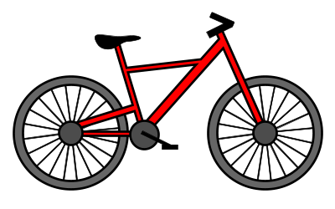     Pauline Mitchell

Principal

Principal

Dear Parents/Caregivers,

This Friday, 22nd May is ‘Walk Safely To School Day’ when we focus particularly on road, bus, scooter and bike safety. This year we are inviting children to bring their bikes or scooters to school to participate in a road safety awareness obstacle course which will be set up on the hard court. **Children must have safety helmets** **in order to participate.** They may bring their bikes or scooters and “park” them at the back of the administration building. They may put their helmets in the classroom. **Bikes and scooters must not be ridden** **in the school playground.** Children should walk them through the school grounds in the interest of student safety. We hope children will enjoy this learning activity and will be reminded of the important rules regarding safety on our roads.

     Pauline Mitchell

Principal

Principal