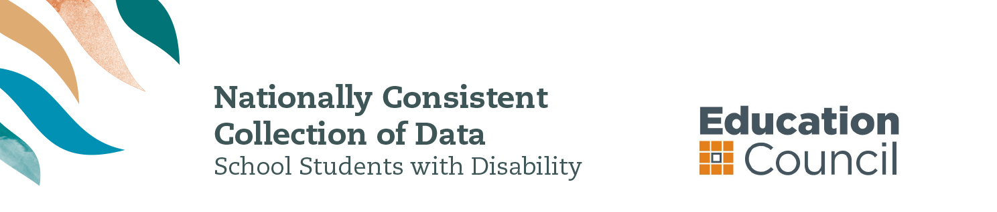

2015 information for parents and carers

WHAT IS THE NATIONAL DATA COLLECTION?
The Nationally Consistent Collection of Data on School Students with Disability (the national data collection) is an annual collection that counts the number of school students with disability and the level of reasonable educational adjustment they are provided with.
The national data collection will count students who have been identified as receiving an adjustment to address a disability under the Disability Discrimination Act 1992 (the DDA). The DDA can be accessed from the ComLaw website at www.comlaw.gov.au.

what is the benefit for my child?
The aim of the national data collection is to collect better information about school students with disability in Australia.
This information will help teachers, principals, education authorities and families to better support students with disability to take part in school on the same basis as students without disability.
The national data collection is an opportunity for schools to review their learning and support systems and processes to continually improve education outcomes for their students with disability.

WHY IS THIS DATA BEING COLLECTED?
All schools across Australia collect information about students with disability. But the type of information currently collected varies between each state and territory and across government, Catholic and independent school sectors.
When implementing the national data collection, every school in Australia will use the same method to collect information. Therefore, a government school in suburban Sydney will collect and report data in the same way as a Catholic school in country Victoria and an independent school in the Northern Territory.
The information provided through the national data collection will enable all Australian governments to better target support and resources to benefit students with disability. The data will help schools to better support students with disability so that they have the same opportunities for a high quality education as students without disability.

WHAT ARE SCHOOLS REQUIRED TO DO FOR STUDENTS WITH DISABILITY?
All students are entitled to a quality learning experience at school.
Schools are required to make reasonable adjustments, where needed, to assist students with disability to access and participate in education free from discrimination and on the same basis as other students.
These responsibilities are outlined in the DDA and the Disability Standards for Education 2005 (the Standards). The Standards require educators, students, parents and others (e.g. allied health professionals) to work together so that students with disability can participate in education. The Standards can be accessed via the ComLaw website at www.comlaw.gov.au.

WHAT IS A REASONABLE ADJUSTMENT?
A reasonable adjustment is a measure or action taken to help a student with disability access and participate in education on the same basis as students without disability. Reasonable adjustments can be made across the whole school setting (e.g. ramps into school buildings), in the classroom (such as adapting class lessons) and at an individual student level (e.g. extra tuition for a student with learning difficulties).

What information will be collected?
Every year your child’s school will collect the following information for each student with a disability:
- the student’s level of education (i.e. primary or secondary)
- the student’s level of adjustment
- the student’s broad type of disability.
The information collected by schools will be provided to all governments to inform policy and programme improvement for students with disability.

WHO WILL BE INCLUDED IN THE NATIONAL DATA COLLECTION?
The definition of disability for the national data collection is based on the broad definition under the DDA.
For the purposes of the national data collection, students with learning difficulties such as dyslexia or auditory processing disorder as well as chronic health conditions like epilepsy, diabetes or asthma, that require active monitoring by the school, may be included.

Who will collect information FOR THE NATIONAL DATA COLLECTION?
Teachers and school staff will identify the number of students with disability in their school and the level of reasonable adjustment they are provided based on:
- consultation with parents and carers in the course of determining and providing reasonable adjustments
- the school team’s observations and professional judgements
- any medical or other professional diagnosis
- other relevant information.
School principals are responsible for ensuring the information identified about each student is accurate.

How will my child’s privacy be protected?
Protecting the privacy and confidentiality of all students and their families is essential. Personal details such as student names or other identifying information will not be provided to local or federal education authorities.
Further information about privacy is available from www.education.gov.au/notices.

IS THE NATIONAL DATA COLLECTION COMPULSORY?
All education ministers agreed to full implementation of the national data collection from 2015. This means that all schools must now collect and report information annually on the number of students with disability in their care and the level of adjustment provided to them.
Information about the arrangements that may apply to your school in relation to this data collection is available from your child’s school principal and the relevant education authority or association of impendent schools.
Even if your child’s information is not included in the national data collection, the school is still required to provide support to your child with education needs.
FURTHER INFORMATION
Contact your child’s school if you have further questions about the Nationally Consistent Collection of Data on School Students with Disability and how it may involve your child.
You can also visit www.education.gov.au/nationally-consistent-collection-data-school-students-disability.
An e-learning resource about the Disability Standards for Education 2005 is freely available for the use of individuals, families and communities at http://resource.dse.theeducationinstitute.edu.au/.

